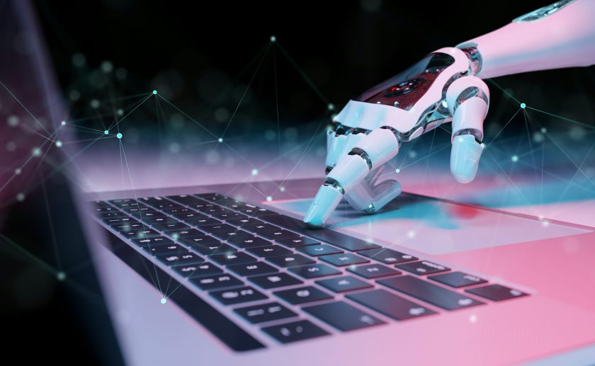

HP

[Email address]

**MUHAMMED HIDASH**

**NSTI Calicut**

**AI Chatbot for Mental Health Relaxation**

**Abstract**

The AI Chatbot for Mental Health Relaxation is designed to provide emotional support and promote mental well-being through advanced conversational technologies. This system utilizes natural language processing (NLP), sentiment analysis, and machine learning algorithms to understand users' emotions and offer personalized relaxation techniques such as breathing exercises, mindfulness guides, and positive affirmations. Additionally, the chatbot can identify signs of severe distress and facilitate connections to licensed psychologists for professional help. By offering immediate, accessible mental health support, this project aims to enhance emotional resilience, improve mental health outcomes, and contribute to overall well-being.

**Table of Contents**

1. Introduction
2. System Architecture
   * Drones
   * IoT Sensors
   * Machine Learning Algorithms
3. Data Collection and Processing
   * Soil Health Monitoring
   * Crop Growth Monitoring
   * Weather Monitoring
4. Analysis and Insights
   * Data Analysis Techniques
   * Actionable Recommendations
5. User Interface
   * Dashboard
   * Mobile App
6. Implementation
   * Hardware Requirements
   * Software Requirements
7. Benefits
8. Challenges and Limitations
9. Future Work
10. Conclusion

**1. Introduction**

The AI Chatbot for Mental Health Relaxation aims to address the growing need for accessible and immediate mental health support. In a fast-paced world where stress and emotional challenges are prevalent, this chatbot leverages advanced technologies such as natural language processing (NLP), sentiment analysis, and machine learning to provide users with personalized emotional support and relaxation techniques. By offering a platform for users to share their feelings and receive tailored advice, the system promotes mental well-being and ensures that individuals can access help whenever they need it. Additionally, the chatbot can detect signs of severe distress and facilitate connections to licensed psychologists, ensuring that users receive comprehensive support. This project seeks to improve mental health outcomes and foster emotional resilience in a convenient and user-friendly manner.

**2. System Architecture**

The system architecture of the AI Chatbot for Mental Health Relaxation comprises three main components: natural language processing (NLP), emotion detection, and personalized recommendations.

**Natural Language Processing (NLP)**

The NLP component is designed to understand and process user inputs effectively. It uses advanced language models to interpret text, identify the context, and engage in meaningful conversations with users. This component ensures the chatbot can understand and respond to a wide range of emotional expressions and queries.

**Emotion Detection**

The emotion detection component utilizes sentiment analysis and machine learning techniques to analyze the emotional tone of user inputs. By identifying patterns in the text, it can gauge the user's emotional state, such as stress, anxiety, or happiness. This continuous analysis helps in tailoring the responses and interventions to the user's current emotional needs.

**Personalized Recommendations**

The personalized recommendations component leverages the insights from the emotion detection module to offer tailored relaxation techniques. These can include breathing exercises, mindfulness and meditation guides, positive affirmations, and music or sound therapy. Additionally, it can identify when a user needs more intensive support and direct them to licensed psychologists or provide emergency contact information.

By integrating these components, the system offers a comprehensive solution for mental health support, ensuring users receive appropriate and effective interventions based on their emotional state.

**3. Data Collection and Processing**

**User Interaction Monitoring**

The chatbot collects data through user interactions, including text inputs and conversational context. This data helps understand the user's emotional state, concerns, and needs. The NLP component processes and interprets this data to maintain a meaningful and supportive conversation.

**Emotional Analysis**

The system uses sentiment analysis and emotion detection algorithms to analyze user inputs. This involves identifying the emotional tone (e.g., stress, anxiety, happiness) and extracting key sentiments from the conversation. This analysis provides insights into the user's mental state and helps tailor the responses accordingly.

**Personalized Intervention Tracking**

The chatbot records the effectiveness of various interventions, such as relaxation techniques, breathing exercises, and mindfulness sessions. By tracking user feedback and outcomes, the system learns which methods are most beneficial for individual users, allowing for continuous improvement and personalization of recommendations.

**Professional Referral Monitoring**

When severe distress or complex mental health issues are detected, the chatbot facilitates connections to licensed psychologists. Data regarding these referrals, including user consent, appointment scheduling, and follow-up interactions, is securely managed to ensure a smooth transition to professional care when needed.

By integrating these data collection and processing components, the system provides a comprehensive and adaptive mental health support experience, ensuring users receive timely and effective assistance based on their unique emotional needs..

**4. Analysis and Insights**

**Data Analysis Techniques**

The chatbot employs advanced machine learning techniques such as sentiment analysis, natural language understanding, and emotion classification to process user interactions. These techniques help identify emotional patterns, detect stress levels, and predict the need for specific interventions.

**Actionable Recommendations**

Based on the analysis, the system offers personalized recommendations such as breathing exercises, mindfulness practices, and positive affirmations. When necessary, it also suggests professional help, ensuring users receive appropriate support to enhance their mental well-being.

**5. User Interface**

**Dashboard**

The system includes a user-friendly dashboard that displays real-time data and insights. Users can view their emotional trends, recent interactions, and personalized relaxation recommendations at a glance.

**Mobile App**

A mobile app provides users with easy access to the chatbot and their mental health insights on the go. The app includes features such as push notifications for timely relaxation tips and reminders for scheduled mindfulness exercises.

**6. Implementation**

**Hardware Requirements**

- Servers for data storage and processing

- Secure communication devices for connecting users to professionals

**Software Requirements**

- Natural language processing frameworks (e.g., GPT-4, spaCy)

- Sentiment analysis tools (e.g., NLTK, TextBlob)

- Dashboard and mobile app development platforms (e.g., React, Flutter)

**7. Benefits**

* Immediate emotional support through accessible chat interactions
* Personalized relaxation techniques tailored to individual needs
* Early detection of severe distress, ensuring timely professional help
* Improved mental well-being through continuous monitoring and feedback
* Anonymity and privacy for users, encouraging open communication

**8. Challenges and Limitations**

* High initial development costs for advanced NLP and machine learning models
* Need for ongoing maintenance and updates to keep the system effective
* Potential data privacy and security concerns
* Ensuring the chatbot can handle a wide range of emotional scenarios accurately

**9. Future Work**

* Integration with additional mental health resources and databases
* Development of more sophisticated emotion detection algorithms
* Expansion to include voice interaction capabilities
* Enhancements in user interface for better accessibility and usability
* Research on reducing costs and improving scalability

**10. Conclusion**

The AI Chatbot for Mental Health Relaxation represents a significant advancement in providing accessible mental health support. By leveraging advanced technologies, it offers personalized assistance to users, promoting emotional well-being and timely intervention. As the system evolves, it holds the promise of transforming mental health care and improving quality of life for many.